

INSTITUTE OF SOFTWARE TECHNOLOGIES

DEPARTMENT OF ORACLE AND REDHAT ADMINISTRATION

INFRAWALK

MORRIS KIMANI N.

This project is submitted in partial fulfilment of requirement for the Institute of Software Technologies award of Diploma in Database Administration and Database App Development

**DECLARATION**

I hereby declare that this project report is based on my original work except for citations and quotations which have been duly acknowledged. I also declare that this has not been previously and concurrently submitted for any other diploma or award in institute of software technologies.

**Morris Kimani Njoroge**

Name:……………………………………….

**December, 2022**

Date:………………………………………

**Supervisor**

I the undersigned do hereby certify that this is a true report for the project undertaken by the above named student under my supervision and that it has been submitted to institute of software technologies with my approval.

Name………………………………………..

Date………………………………………..

**ACKNOWLEDGEMENTS**

I would like to thank everyone who had contributed to the successful completion of this project. I would like to express my gratitude to my research supervisor, Mr. Sammy Kibet for his valuable input as well as my friend Joseph for guidance on implementation options of this project.

In addition, I would also like to express my gratitude to my loving Mother for her seeing me through this course up to the point I am now in its completion not forgetting the many other people who made this journey worthwhile

**TABLE OF COONTENTS**

Contents

CHAPTER ONE 1

INTRODUCTION 1

PROBLEM STATEMENT 1

OBJECTIVES 2

SCOPE 2

PROJECT SCHEDULE 2

CHAPTER TWO 3

LITERATURE REVIEW 3

CHAPTER THREE 4

METHODOLOGY 4

CHAPTER FOUR 5

SYSTEM ANALYSIS AND REQUIREMENT MODELLING 5

CHAPTER FIVE 6

SYSTEM DESIGN 6

CHAPTER SIX 7

SYSTEM IMPLEMENTATION 7

CHAPTER SEVEN 8

LIMITATIONS, CONCLUSIONS AND RECOMMENDATIONS 8

1. LIMITATIONS 8

2. CONCLUSIONS 8

3. RECOMMENDATIONS 8

**LIST OF FIGURES/ILLUSTRATIONS**

Figure 1: Scrum Methodology 4

# CHAPTER ONE

## INTRODUCTION

Asset management is an important area in all organizations and institutions. In this project, I will be looking into a way to use this little talked about section of management to benefit students and put to use the assets of an institution while being able to accurately track them as they are distributed to those that need them for educational purposes.

## PROBLEM STATEMENT

Many students (I included) have had a difficult time trying to install and work with the various technologies taught in the school. These include: oracle databases, Linux/Windows servers among other tools used for learning. This is majorly due to a number of factors which include:

1. **Single Use:** Working with these tools require consistent practice which may include frequent reinstallation that mimics a real world environment. Once an OS is installed on a student’s personal computer it becomes hard to keep practicing installation and setup since there is a risk of data loss
2. **Poor PC Specs:** Not all students will be able to have high performance personal computers to run software such as Oracle Database, SQL Developer and Oracle Forms at the same time since they are quite resource intensive in terms of storage space and processing power usage. This can be very frustrating.
3. **Sandboxes:** Learning requires the constant use of a sandbox in which scripts and concepts can be taught. In my experience, I could not play around with the class provided server since it was being used by other students as well.
4. **Resource constraints:** Some times, not all the computers in the lab were loaded with the required software or some had passwords that locked students out of them. Access to the computer lab is also restrictive during the weekends or evenings which may be when most students are available.
5. **Idle Resources:** There are a number of servers that lay dormant and unused which if well utilized can help many students.

## OBJECTIVES

The objective of this project is quite simple; allow the proper cataloging of the infrastructure that is available within the institution. This will be summed up in the following points:

1. **Inventory:** Make it easier to inventory all the hardware and software that is available in the institution both usable and unusable by students.
2. **Security:** With adequate information on all the infrastructure in the institution, make it easier to secure this infrastructure with VPNs and other kinds digital security features.
3. Make it easier to access information on how students are equipped based on how many actively use their sandboxed environments.
4. Expand the scope of the institution to renting out unused resources to other institutions and even companies as this will be a proof of concept of how well the infrastructure can be managed.
5. Create a system that is easy to use and reduce the effort needed to access information on the go.

## SCOPE

This Software Design Document will cover the basic but critical parts of the system hence acting as a proof of concept that it is feasible for largescale use with emphasis being on data collection, manipulating and storage of information. The system will be used in conjunction with existing systems if there is one in existence.

This document contains a complete description of the design of the Infrawalk. Its basic structure is a Client-Server paradigm. Basic forms will be created and coded in Oracle Forms. An out dated Technology but it will serve the purpose for this proof of concept before exploration of better and simpler tools for this project.

Staff that will be designated to use the system will be able to make changes to the data that has already been entered into the system as well as use some basic tools built into the system to create reports.

## PROJECT SCHEDULE

The development of this project should not take more than three months. This includes the various steps followed during the development of software and finally testing and rolling out of the software. Below is a chart to describe the timelines that will be followed.

# CHAPTER TWO

## LITERATURE REVIEW

Asset management software has been in existence for a long time. Some popular ones include: inflow, LightSpeed Retail and Upserve. Generally, they are all build to perform very well and ensure top notch asset tracking for their users. However, even with the advantages they provide: there are several pitfalls that they face which include:

1. System hacks due to most being accessible over the internet and hence cannot be housed within the organization
2. A large learning curve as they are built for general use, not a specific use case like Infrawalk.
3. Inability to confirm inventory as all rely only on the data that has been keyed in. Infrawalk will provide real-time confirmation of it’s inventory.
4. Recurrent costs of renting the software and slow evolution.

# CHAPTER THREE

## METHODOLOGY

For this project, the preferred methodology is **Scrum Methodology**. It is the best methodology for this project because of the following reasons:

* **Time**: The time constraints for this project require it to be complete as fast as possible.
* **Project type:** With the project size being small, Scrum is optimized for handling small scale projects like this one.
* **Progress:** It is easy to monitor the progress of the project since there are milestones set for each iteration of the scrum. Regular feedback from consistent testing allows for problems to be detected and resolved very quickly.
* **Deadlines:** With strict control of deadlines, delivery on specified features is achievable.

Figure : Scrum Methodology

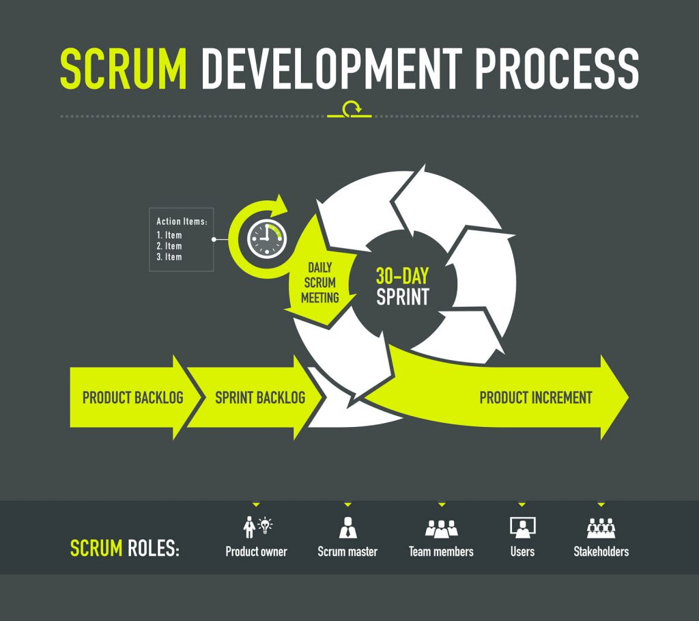

# CHAPTER FOUR

## SYSTEM ANALYSIS AND REQUIREMENT MODELLING

Software development can be done using.

# CHAPTER FIVE

## SYSTEM DESIGN

Software development can be done using

# CHAPTER SIX

## SYSTEM IMPLEMENTATION

Software development can be done using

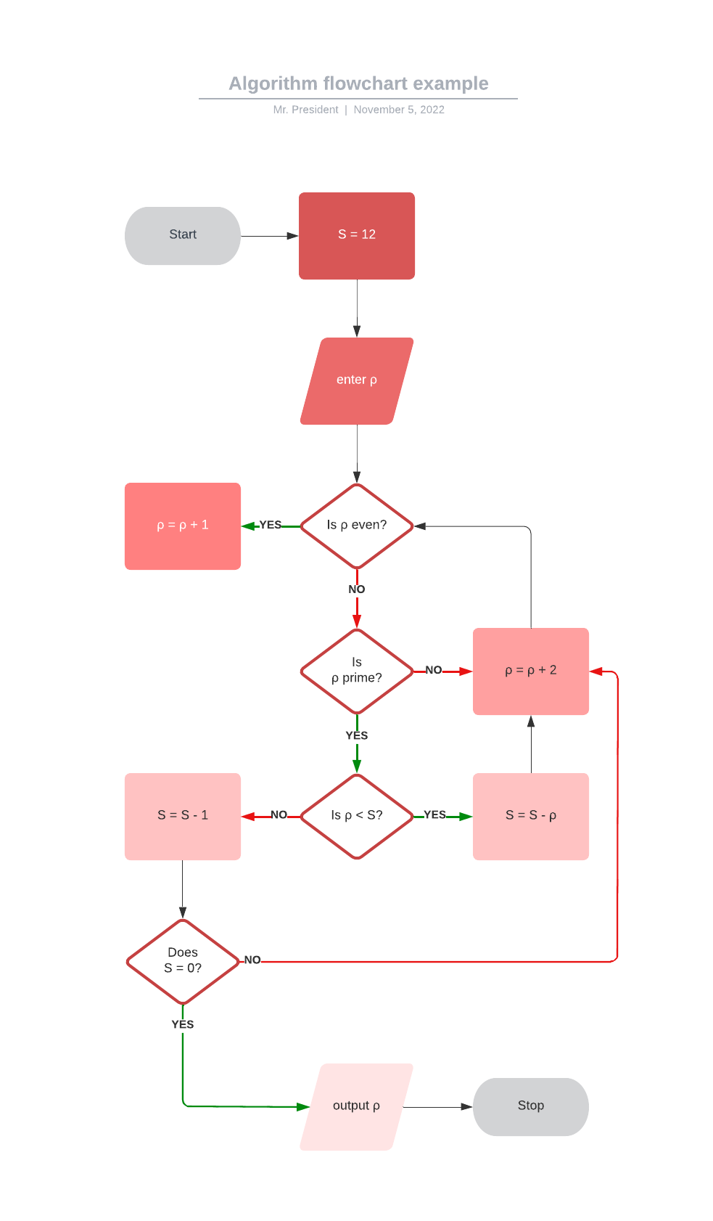

# CHAPTER SEVEN

## LIMITATIONS, CONCLUSIONS AND RECOMMENDATIONS

During the development of this system, there are a number of problems that I encountered and I have classified them into a few major categories

### LIMITATIONS

1. **Research:** The major problem was how little information was available on setting up the development environment that was intended for the project. The difference in technology of how 10g Forms and Reports work with 12c Oracle Databases. I feel that Oracle Forms and Reports are an outdated technology and the use of either ADF or pure Java will make it easier to develop this kind of system with Oracle running as the Database.
2. **Development:** PL/SQL was a major challenge to put together on forms and run so I decided to run all the operations on the server side. This relieved the client computer. Setting up Oracle Forms 10g was an impossible task as it refused to connect to the Oracle 12c database and so I ended up using HTML, CSS and JavaScript for the user interface and Java for the backend.
3. **Time:** The time allocated to the project was mainly used up in setting the environment of development. It would have gone to more meaningful research and development if a better technology like ADF for the user interface was used.
4. **Running:** As the Database and system were running on two different operating systems namely Oracle Linux 7.9 and Windows 10 respectfully. This was not much of an issue except for the fact that ensuring that the two modules were communicating was a bit of a challenge.

### CONCLUSIONS

### RECOMMENDATIONS

# References

*Scrum Methodology*. (2022, 10 31). Retrieved from Digite: https://www.digite.com/agile/scrum-methodology/